DOCUMENT 34 — QA, Testing & Release Engineering
Visionary Internal · v1.0 · Shipping safely to children

A bug in a billing system costs money; a bug in a teaching system costs trust.
Release engineering is gated by pedagogical evals, not just unit tests.

1. The Testing Pyramid
- Unit/Integration: Standard Jest/PyTest. 100% coverage on SCM math, BKT updates,
RBAC, and billing ledger.
- Contract Tests: Verify zero cross-role data leaks (Doc 08 KF2). Run on every PR.
- Device Lab: Automated UI tests on physical Redmi Note 9 / low-end Android via
Appium. Verifies 30fps 3D, TTI ≤2.5s, and Indic rendering.
- Eval Suite (IndiaEdTech-Bench): 500 canonical pedagogical scenarios. Run against
the LLM before any prompt change or model promotion (Doc 10).

2. Release Pipeline
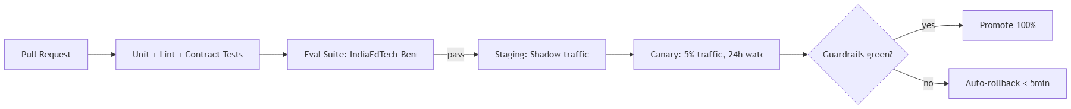

3. Rules
- No teaching-behavior change ships without an A/B experiment flag (Doc 28).
- Model registry promotions require ML-lead + SME sign-off.
- Rollback time must be <5 minutes; state must be preserved during rollback.

OKF
KF1 CI blocks merge on contract test failure · KF2 Eval suite runs in <15 min ·
KF3 Device lab runs nightly on physical hardware · KF4 Canary auto-rollback triggers on
2% drop in comprehension pass-rate · KF5 zero unflagged deploys to production.

